**1. SDLC OVERVIEW**

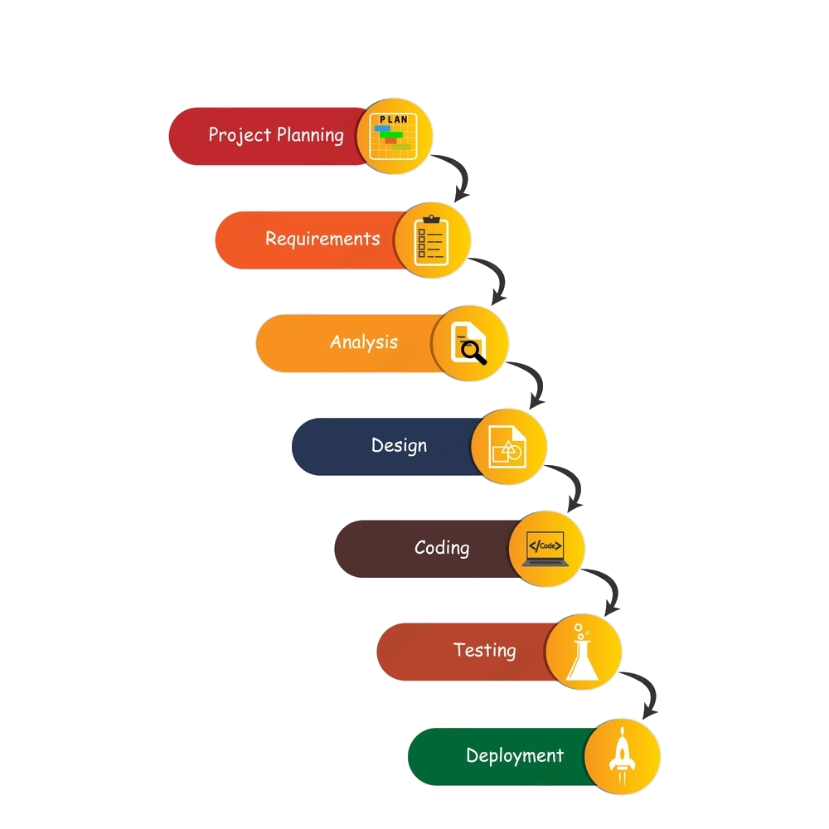

**Waterfall Model**

* We are using Waterfall Model because each phase must be completed before the next phase can begin, and it is planned in advance and cannot be changed.
* Phases are prescribed and are at a time.
* Cannot repeat previous steps.

It is termed a waterfall because we cannot go back to any phase in a downward direction.

**2. REQUIREMENT GATHERING AND ANALYSIS**

* 1. **ORGANIZATION DETAILS:**

**1. Name of the Organization: -**

CarServ

**2. Brief detail of the organization: -**

CarServ is best place for servicing and maintaining your car and it is providing online slot booking for servicing the car.

* 1. **MEETINGS:**

**I. Meeting with Client**

**1. Name of Client**

- Mr. Kapil Thaker

**2. Client requirement in his words.**

- Online slot booking, messages, notification, etc. for client.

**2.3 Data which will be the input into the system….**

* Text
* Images

**2.4 Data which will be the output from the system….**

* Text
* Images

**2.5 Type of project….**

* Online

**2.6 Method for collecting data.**

* Interview.

**3. SYSTEM REQUIREMENT SPECIFICATIONS**

**3.1 Introduction:**

**3.1.1 Purpose:**

CARSERV is an Online Service booking Web Application which provides online booking for car service. All users can booking online via Internet Connection & can view them.

* + 1. **Intended Audience and Reading Suggestions:**

The intended audience of this document is the potential end user. The document may also serve as a reference guide to the developers of the system.

* + 1. **Product Scope:**

The application produced will be an online car service booking. Everyone can download and use this Web application.

* 1. **Overall Description:**
     1. **Product Function:**

1. **Admin Module :**

* Login
* Add Subject
* Remove Subject
* Upload Materials
* Maintain Database

1. **User Module :**

* Register
* Login
* Update Profile
* Download Pdf
  + 1. **User classes and characteristics:**

1. **User Classes :**

* Administrator
* User

1. **User Characteristics :**
2. Administrator:

Admin must be capable to manage Database & Materials.

1. User :

User should have basic idea about webapplication operations.

* + 1. **Operating Environment:**

This App will operated through the internet including hardware platforms like operating system Windows, Linux, and Android.

* + 1. **Design and Implementation constraints:**
* GUI is only in English.
* Internet connection is required.
* Users should have basic knowledge of Mobile Handset.
  + 1. **Assumptions and dependencies:**
* Administrator is created in the system already.
* The database will be managed by the admin only.
* Roles and tasks are predefined.

**3.3 External Interface Requirement:**

**3.3.1 User Interface:**

In case the user is not registered. He/She can enter the details and create an account. Once the account is created user can ‘login’. If the username or password is incorrect then an error message appears.

**3.3.2 Software Interface:**

* Operating System – Windows
* Front End – ASP.NET
* Back End – SQL Server - 2014
* Software for Front End – Visual Studio
* Communication Interface – Browser
  1. **System Features:**
* To provide user login.
* To show Car Service Slot.

* 1. **Other Nonfunctional Requirements:**

**3.5.1 Performance requirement:**

* Overall System should be fast and error free.
* It should have built in error checking and correction facilities.
* The system should be able to handle large amount of data.
  + 1. **Security Requirement:**
* Administrator has more rights than user.
  + 1. **Safety Requirement**:
* In order to prevent data loss in case of system failure, the Pdf are saved in the database and can be downloaded from remote system.
  1. **Feasibility Study**

A feasibility study is a preliminary investigation of a proposed system to decide whether the system can run smoothly with the organization.

**3.6.1 Operational Feasibility: -**

Operational feasibility is the measure of how well a proposed system solves the problems, and takes advantage of the opportunities identified during scope definition and how it satisfies the requirements identified in the requirements analysis phase of system development

**3.6.2 Technical Feasibility: -**

Technical feasibility determines whether the work for the project can be done with the existing equipment, software technology and available personal.

Technical feasibility is concerned with specifying equipment and software that will satisfy the user requirement.

**3.6.3 Economic Feasibility: -**

Economic feasibility determines whether there are sufficient benefits in creating to make the cost acceptable, or is the cost of the system too high.

So this signifies cost benefit analysis and savings on the behalf of the cost benefit analysis.

**3.6.4 Schedule Feasibility: -**

How long will it take to get the technical expertise?

We may have the technology, but that doesn’t mean we have the skills required to properly apply that technology.

1. **SYSTEM ANALYSIS AND MODELING**
   1. **Use case Diagram:**

**1) Admin Side**

Login

Manage

Slot

Manage

Users

Manage

Request

View

Inquiry

**ADMIN**

**2) User Side**

Register

Login

View

Car Slot

Add

Inquiry

Book

Service

**USER**

* 1. **Normalization & E-R Diagram:**

Normalization is the process of organizing the [columns](https://en.wikipedia.org/wiki/Column_(database)) (attributes) and [tables](https://en.wikipedia.org/wiki/Table_(database)) (relations) of a [relational database](https://en.wikipedia.org/wiki/Relational_database) to reduce [data redundancy](https://en.wikipedia.org/wiki/Data_redundancy) and improve data integrity.

* **Un-Normalized Data:**

|  |  |  |  |  |  |
| --- | --- | --- | --- | --- | --- |
| userid | username | slotid | Slot_time | Car_number | User_password |
| 1 | Rahul | 1 | 10:00-12:00 | GJ 10 DS  2653 | rahul567 |
| 2 | Manav | 2 | 09:00-11:00 | GJ 10 AC  8666 | m111 |
| 3 | Kapil | 3 | 13:00-15:00 | GJ 10 AB  7824 | kapilt |

* **Normalized Form:**

1. **1st Normal Form:**

|  |  |  |  |  |
| --- | --- | --- | --- | --- |
| id * (AI) | Fullname | Mobile | Email | Password. |
| 1 | Rahul | 9499815372 | rahul@gmail.com | rahul567 |
| 2 | Manav | 8141828209 | manav@gmail.com | m111 |

1. **Table Name :** Users

**Primary Key:** id (Auto Increment)

1. **Table Name :** AdminLogin

**Primary Key:** id (Auto Increment)

|  |  |  |
| --- | --- | --- |
| id * (AI) | Username | Password |
| 1 | Admin | Admin |

1. **2nd Normal Form:**
2. **Table Name :** Slot

**Primary Key:** id (Auto Increment)

|  |  |  |  |
| --- | --- | --- | --- |
| id *(AI) | Day | Time | Status |
| 1 | Monday | 9:00-11:00 | unoccupied |
| 2 | Tuesday | 13:00-15:00 | occupied |

1. **Table Name :** Inquiry

**Primary Key:** id(Auto Increment)

**Foreign Key:** userid,slotdetailsid,serviced,

|  |  |  |  |
| --- | --- | --- | --- |
| id  *(AI) | Status | Userid | slotid |
| 1 | Accept | 1 | 1 |
| 2 | Decline | 2 | 2 |

1. **Table Name :** CarDetails

**Primary Key :** id(Auto Increment)

|  |  |  |  |  |  |
| --- | --- | --- | --- | --- | --- |
| Id  *(AI) | Carname | CarNo | Model | Problem | Userid |
| 1 | Wagnor | GJ 10 BC 9351 | New | Nothing | 1 |
| 2 | BMW | GJ 10 DP 2851 | Old | Oli change | 2 |

* **E-R Diagram:**

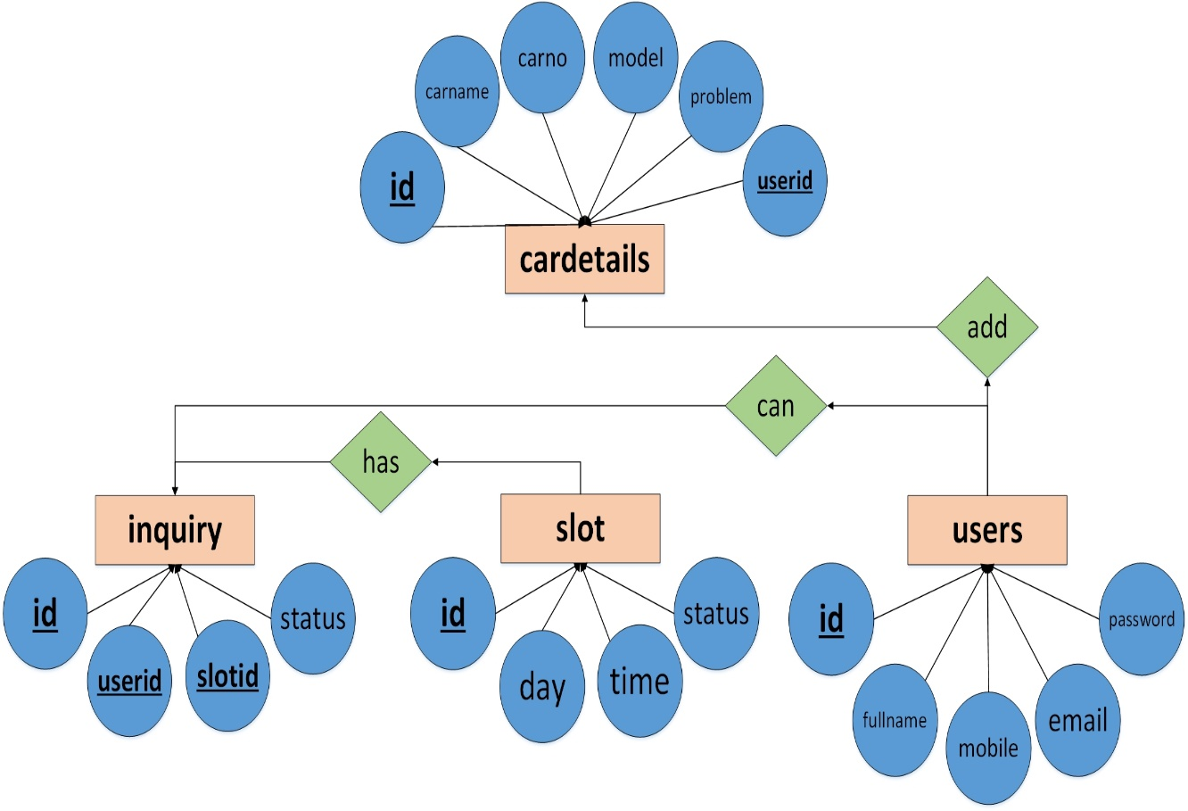

* 1. **Data Dictionary**

1. **Users:**

|  |  |  |  |  |
| --- | --- | --- | --- | --- |
| SRNO. | COLUMN NAME | DATATYPE | NULL | Description |
| 1 | id* | Int(11) | NO | Primary Key, Auto Increment |
| 3 | full name | Varchar(50) | NO |  |
| 4 | mobile no. | Varchar(50) | NO |  |
| 5 | email | Varchar(50) | NO |  |
| 6 | password | Varchar(50) | NO |  |

1. **Slot:**

|  |  |  |  |  |
| --- | --- | --- | --- | --- |
| SRNO. | COLUMN NAME | DATATYPE | NULL | COMMENTS |
| 1 | id* | Int(11) | NO | Primary Key, Auto Increment |
| 2 | day | Varchar(50) | NO |  |
| 3 | time | Varchar(50) | NO |  |
| 4 | Status | Varchar(50) | NO |  |

1. **Inquiry:**

|  |  |  |  |  |
| --- | --- | --- | --- | --- |
| SRNO. | COLUMN NAME | DATATYPE | NULL | COMMENTS |
| 1 | id* | Int(11) | NO | Primary Key, Auto Increment |
| 3 | userid | Varchar(50) | NO | Foreign Key |
| 4 | sloteid | Varchar(50) | NO | Foreign Key |
| 5 | status | Varchar(50) | NO |  |

1. **Contact:**

|  |  |  |  |  |
| --- | --- | --- | --- | --- |
| SRNO. | COLUMN NAME | DATATYPE | NULL | COMMENTS |
| 1 | id* | Int(11) | NO | Primary Key, Auto Increment |
| 2 | name | Varchar(50) | NO |  |
| 3 | email | Varchar(50) | NO |  |
| 4 | subject | Varchar(50) | NO |  |
| 5 | message | Varchar(50) | NO |  |

1. **Cardetails:**

|  |  |  |  |  |
| --- | --- | --- | --- | --- |
| SRNO. | COLUMN  NAME | DATATYPE | NULL | COMMENTS |
| 1 | id* | Int(11) | NO | Primary Key, Auto Increment |
| 2 | carname | Varchar(50) | NO |  |
| 3 | carno. | Varchar(50) | NO |  |
| 4 | model | Varchar(50) | NO |  |
| 5 | problem | Varchar(50) | NO |  |
| 6 | userid | Varchar(50) | NO | Foreign Key |

|  |  |  |  |  |
| --- | --- | --- | --- | --- |
| SRNO. | COLUMN  NAME | DATATYPE | NULL | COMMENTS |
| 1 | Id | Id(11) | NO | Primary Key,Auto Increment |
| 2 | Username | Varchar(50) | NO |  |
| 3 | Password | Varchar(50) | NO |  |

1. **Admin:**

**4.4 Functional and behavior modeling**

* + 1. **Context Diagram(0-level Diagram)**

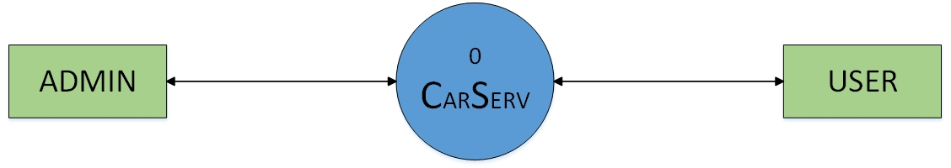

**4.3.2 First Level Diagram (1-level Diagram)**

* **ADMIN**

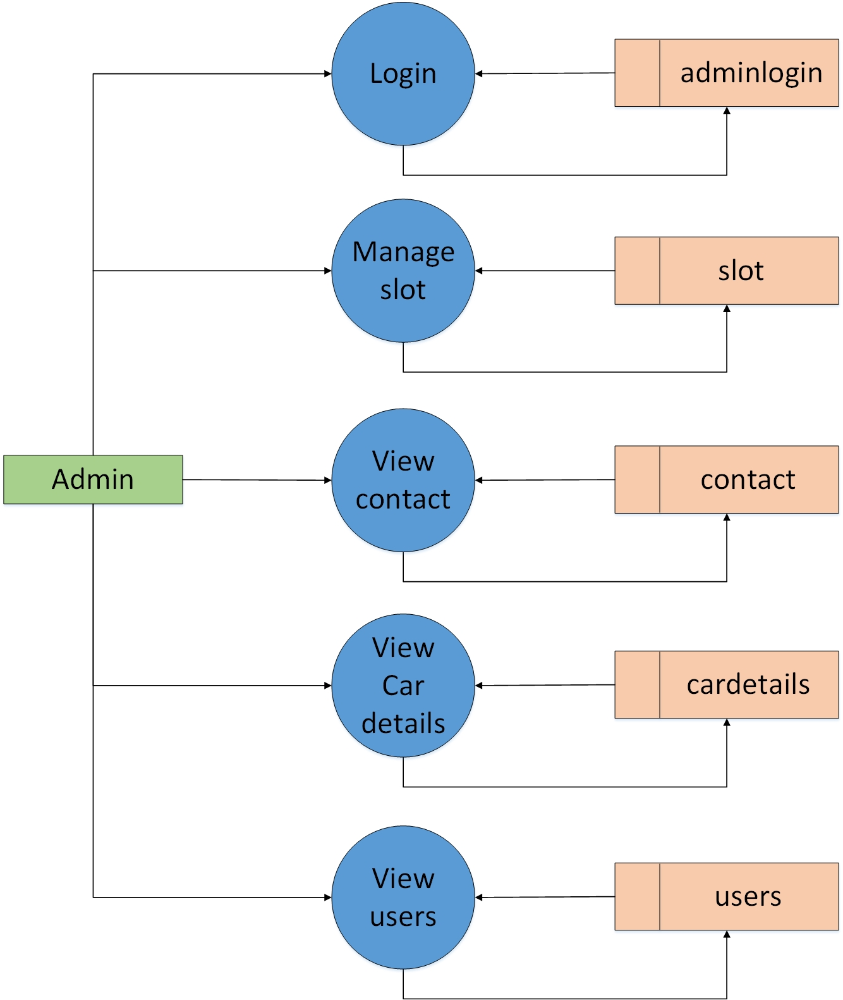

* **USER**

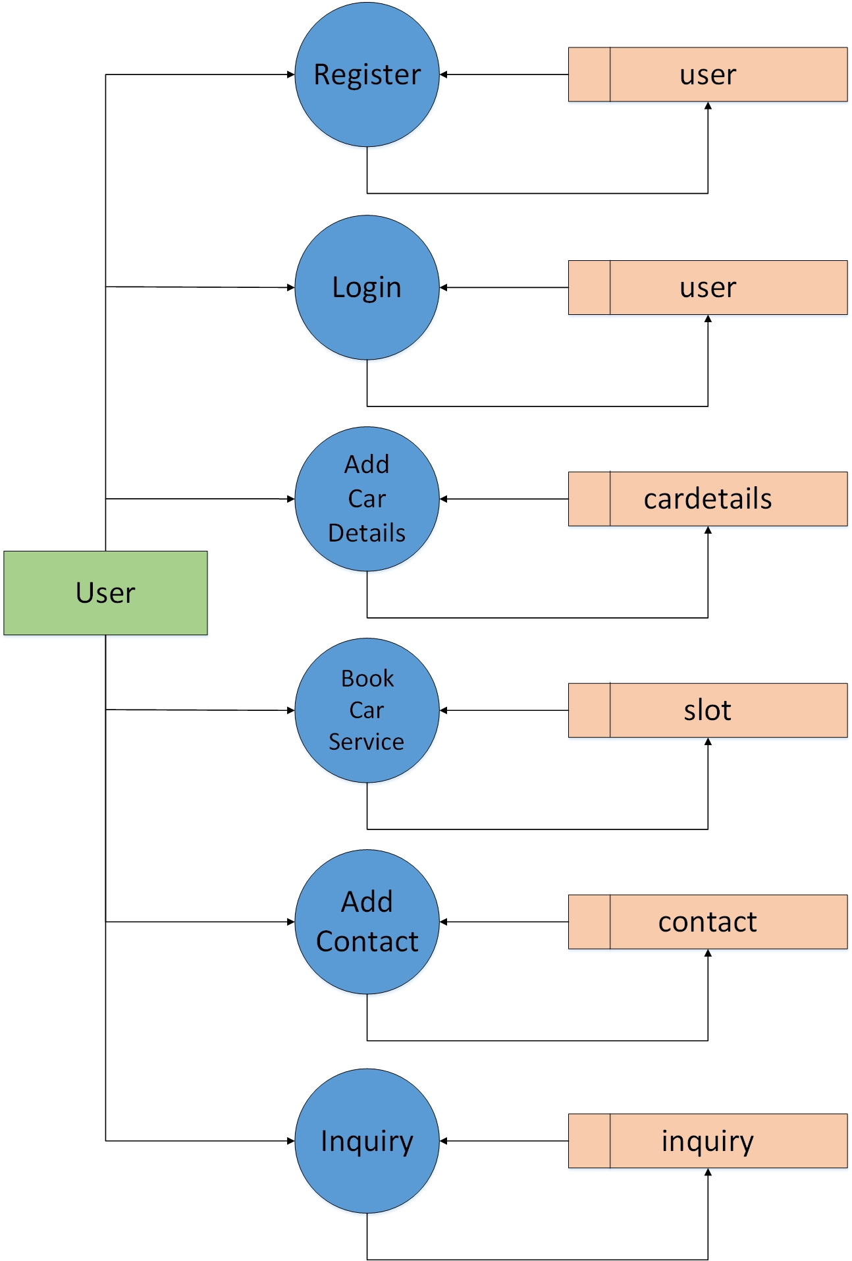

**4.4 Gantt Chart**

* Expected Time.
* Actual Time.

|  |  |  |  |  |  |
| --- | --- | --- | --- | --- | --- |
| No. | Task | June | July | August | September |
| 1 | Requirement Gathering And SRS |  | | | |
| 2 | System Analysis |  | | | |
| 3 | System Design |  | | | |
| 4 | System Development |  | | | |
| 5 | System Testing |  | | | |

1. **TEST CASE**

|  |  |  |  |  |  |
| --- | --- | --- | --- | --- | --- |
| Login Module | | | | | |
| TEST CASE No. 1 | | | TEST CASE DESIGN DATE : 25/Sep/2023 | | |
| TEST TITLE : Login Module Test | | | TEST CASE EXECUTION DATE : 25/Sep/2023 | | |
| DESCRIPTION : In this test case Login module would be tested | | | | | |
| PRECONDITION : Login Activity must be working | | | | | |
| STEP No. | TEST STEP | TEST DATA | EXPECTED RESULT | ACTUAL RESULT | STATUS |
| 1 | Navigate to Login Page | Login Activity | Login Activity is visible | Same As Expected | PASS |
| 2 | Enter Email | admin@gmail | Email is accepted | Invalid Email | FAIL |
| 3 | Enter Password­­­­­ | admin123 | Password is accepted | Same As Expected | PASS |
| 4 | Click Login Button | Button Click | Check Credentials | Same As Expected | PASS |

* Note :- Email is not accepted in above test case due to invalid format.

|  |  |  |  |  |  |
| --- | --- | --- | --- | --- | --- |
| Signup Module | | | | | |
| TEST CASE No. 2 | | | TEST CASE DESIGN DATE :  25/Sep/2023 | | |
| TEST TITLE : Signup Module Test | | | TEST CASE EXECUTION DATE : 25/Sep/2023 | | |
| DESCRIPTION : In this test case Signup Activity would be tested | | | | | |
| PRECONDITION : Signup Activity must be working | | | | | |
| STEP No. | TEST STEP | TEST DATA | EXPECTED RESULT | ACTUAL RESULT | STATUS |
| 1 | Navigate to Signup Activity | Signup Activity | Signup Activity is visible | Same As Expected | PASS |
| 2 | Enter All Fields | Data | Check Data Integrity | Same As Expected | PASS |
| 4 | Click Signup Button | Button Click | Signup done  With all Validation | Same As Expected | PASS |

1. **SCREEN SHOTS**

* **Admin Side**
* **Login Page**

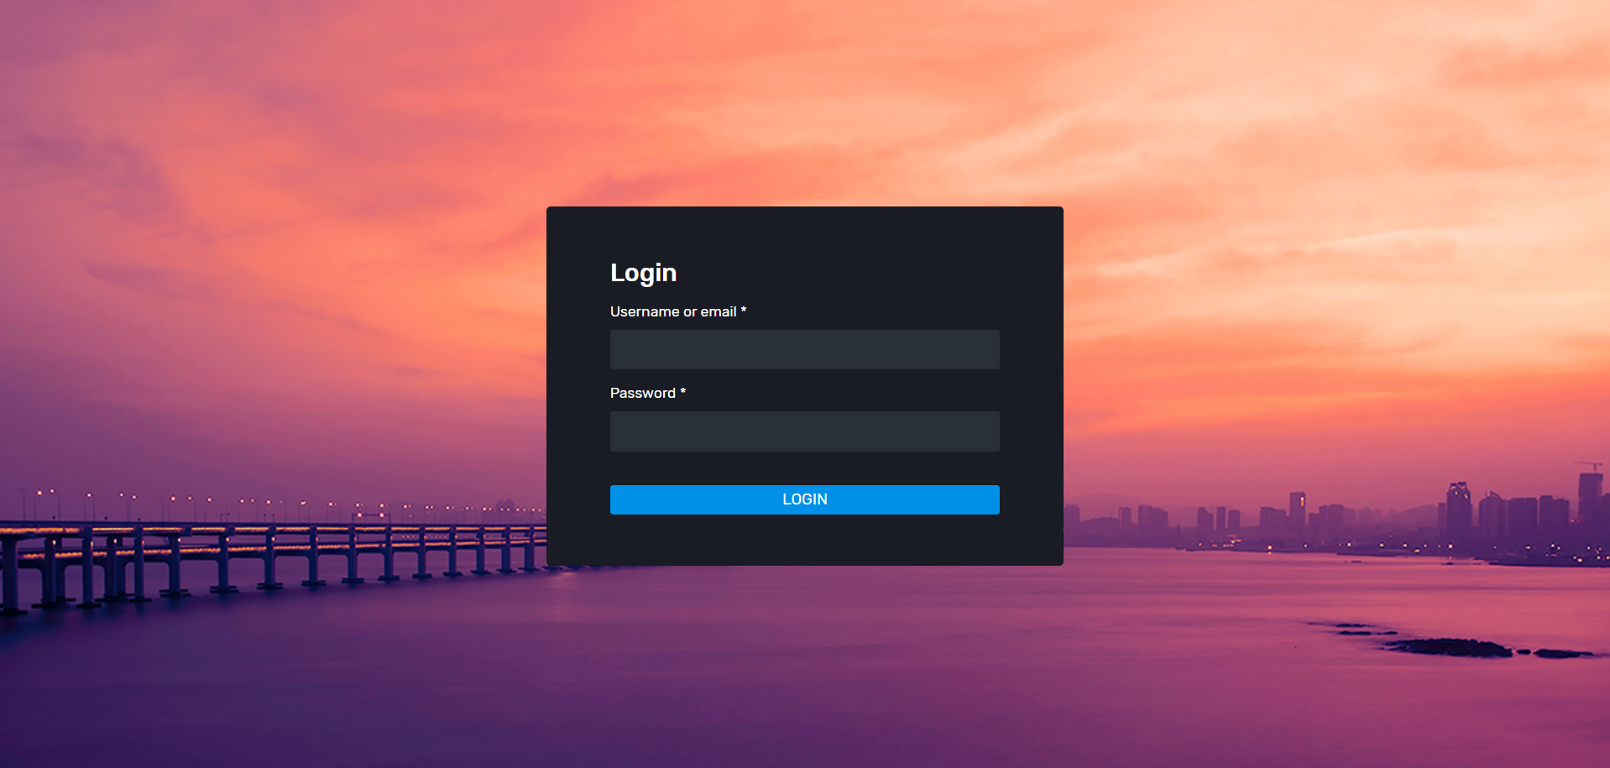

* **Dashboard Page**

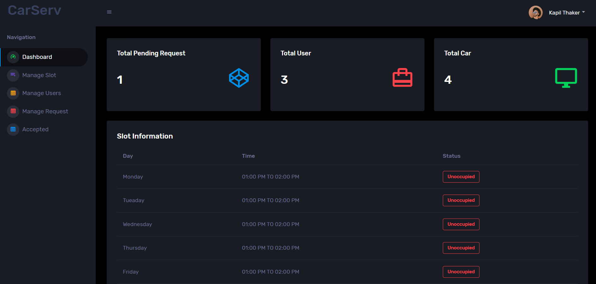

* **Slot Page**

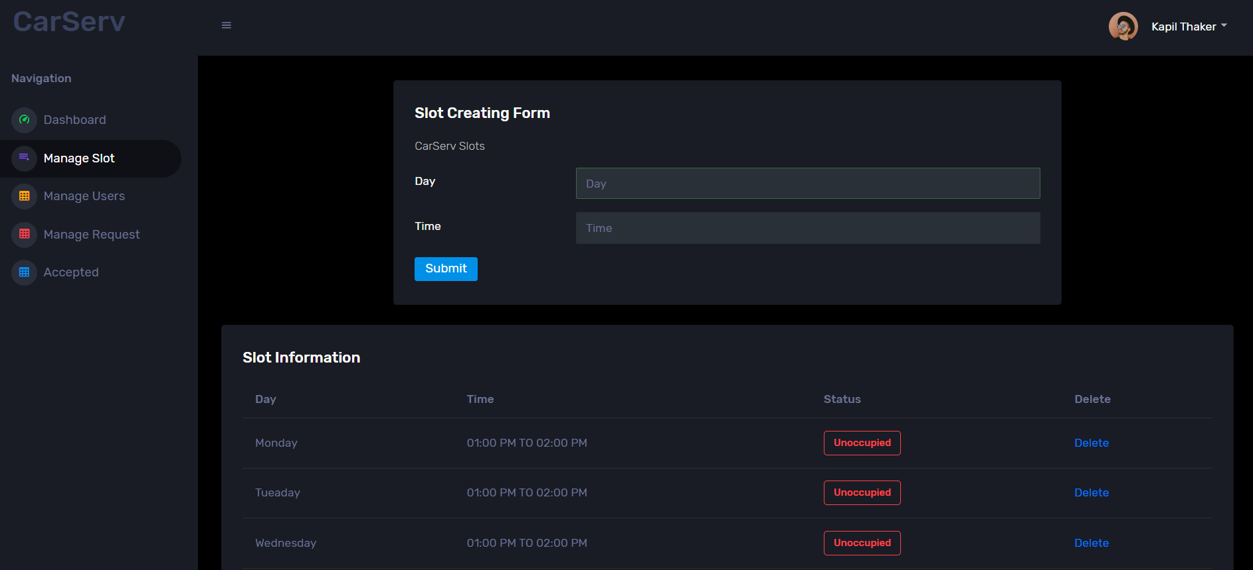

* **User Page**

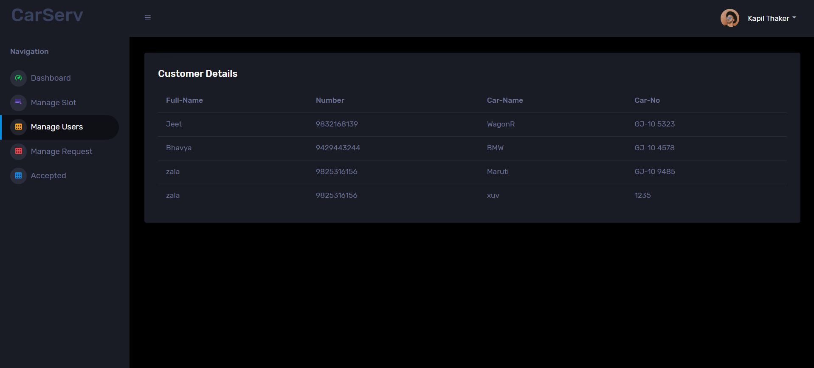

* **Manage Request**

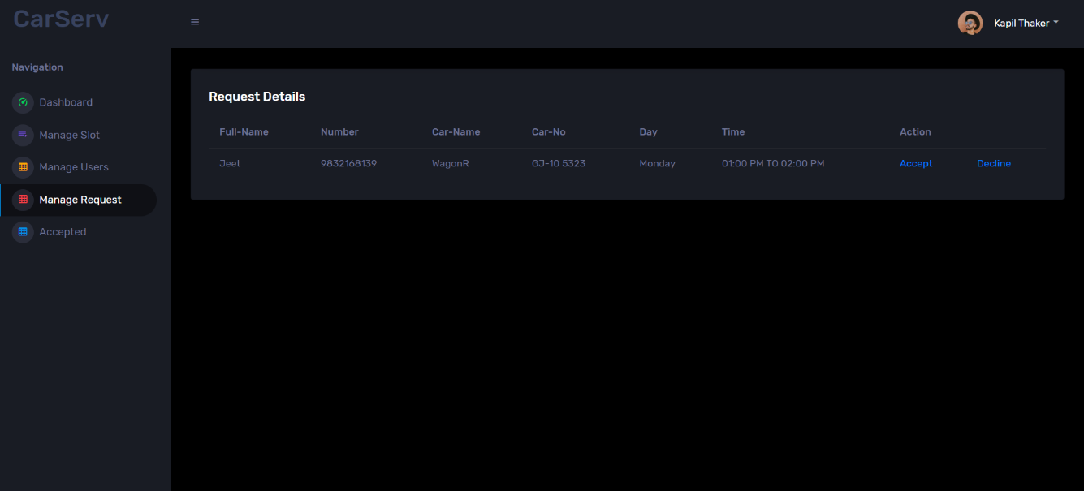

* **Accepted Request**

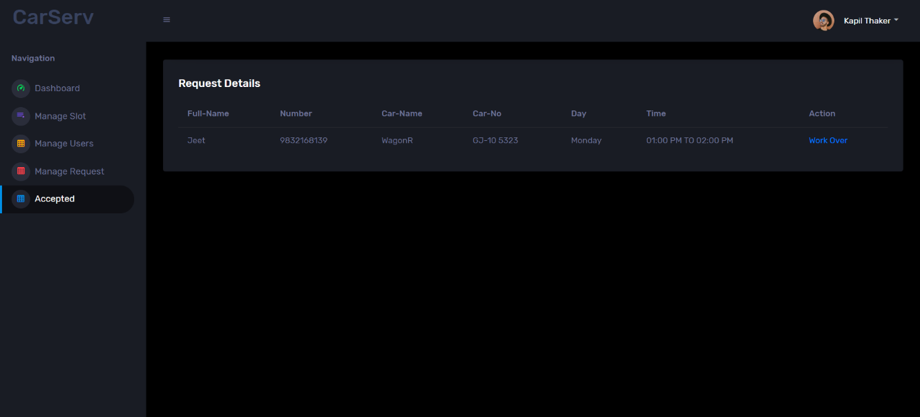

* **User Side**
* **Login Page**

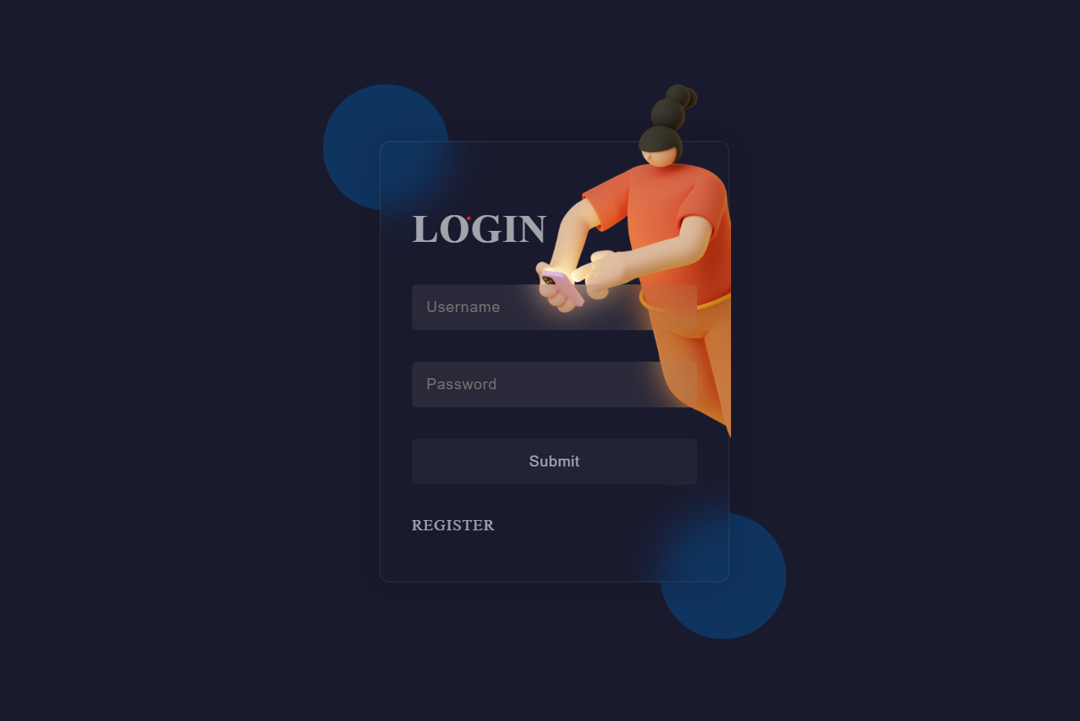

* **Register Page**

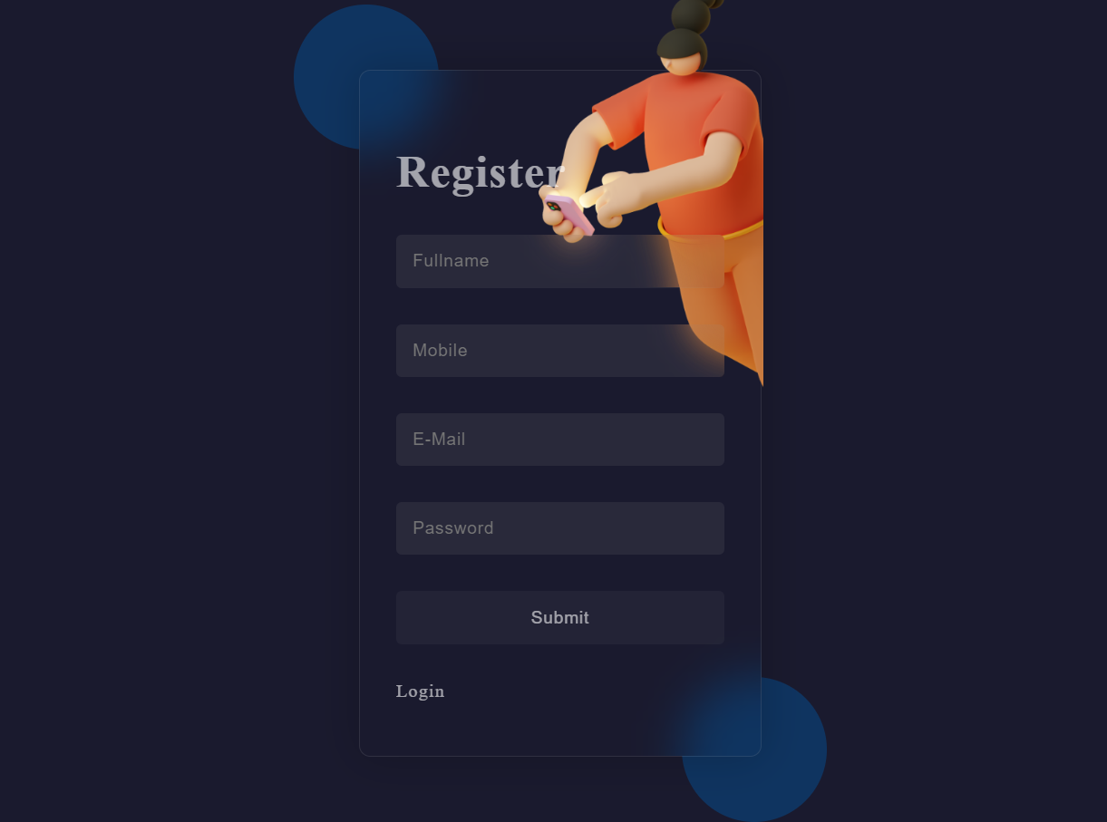

* **Home Page**

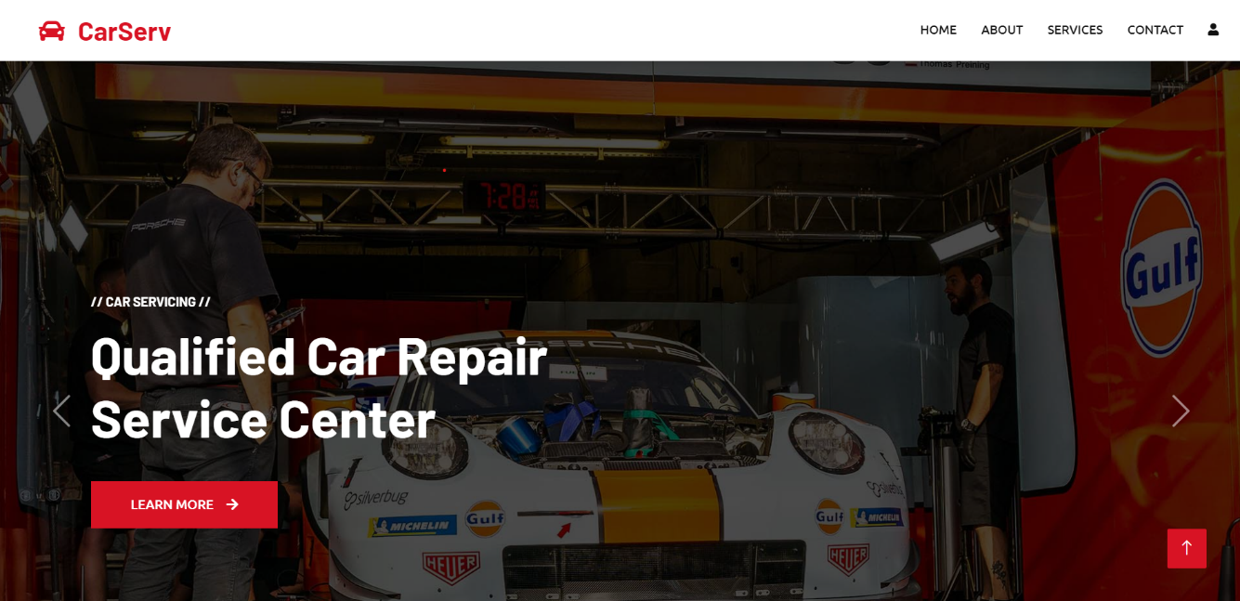

* **Aboutus Page**

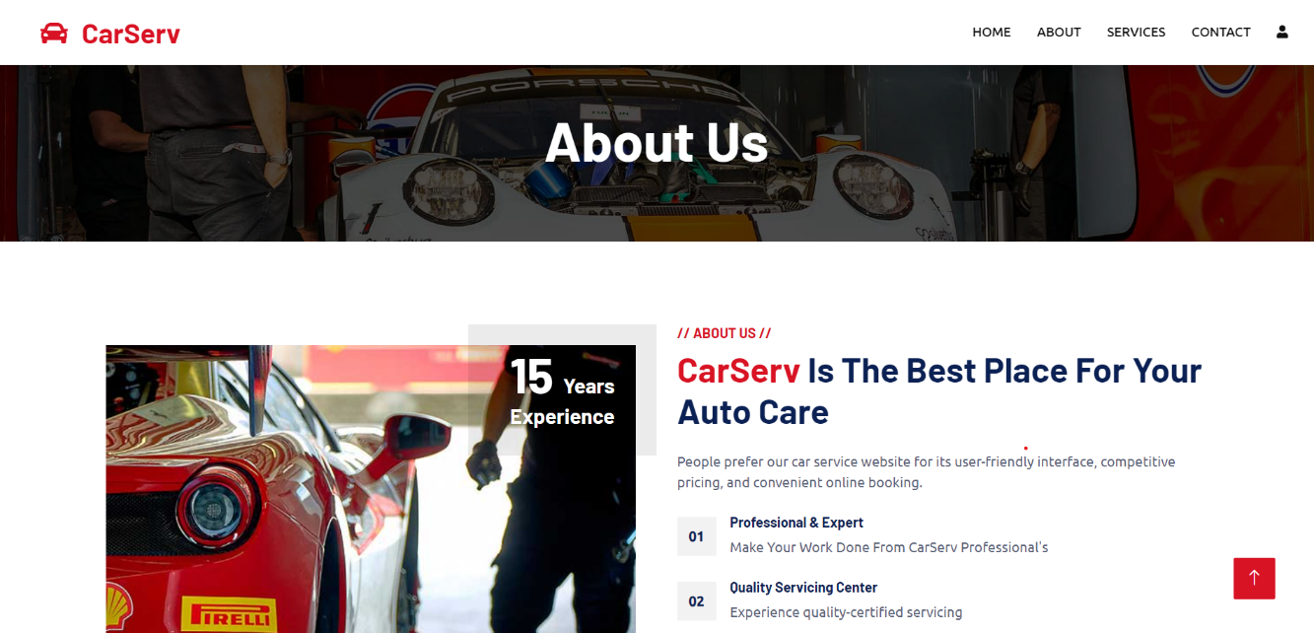

* **Services Page**

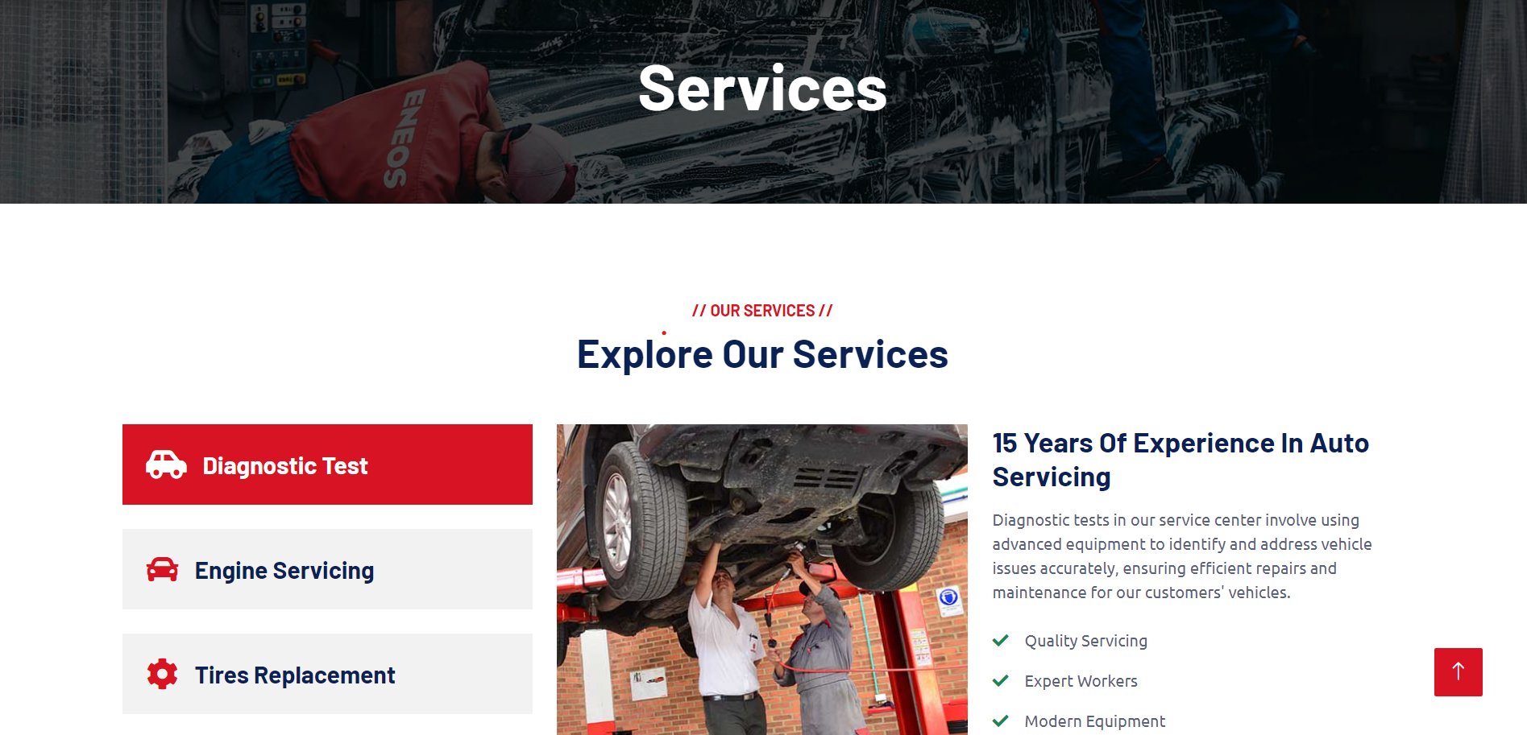

* **Contact Page**

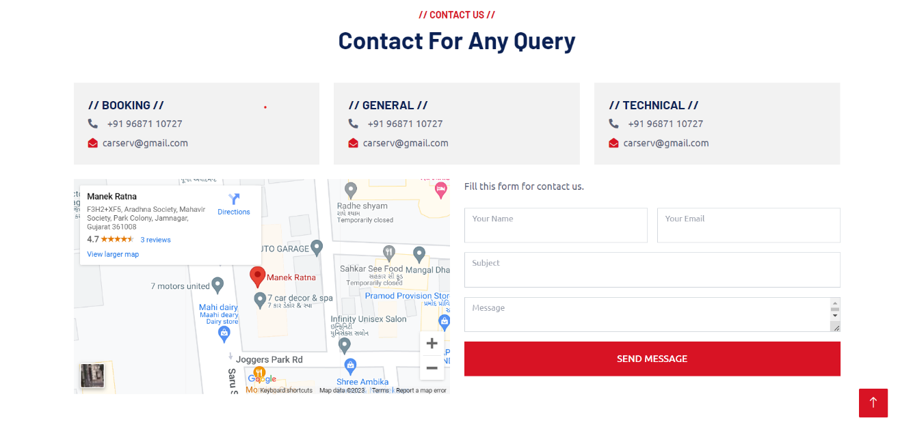

* **Register Car Page**

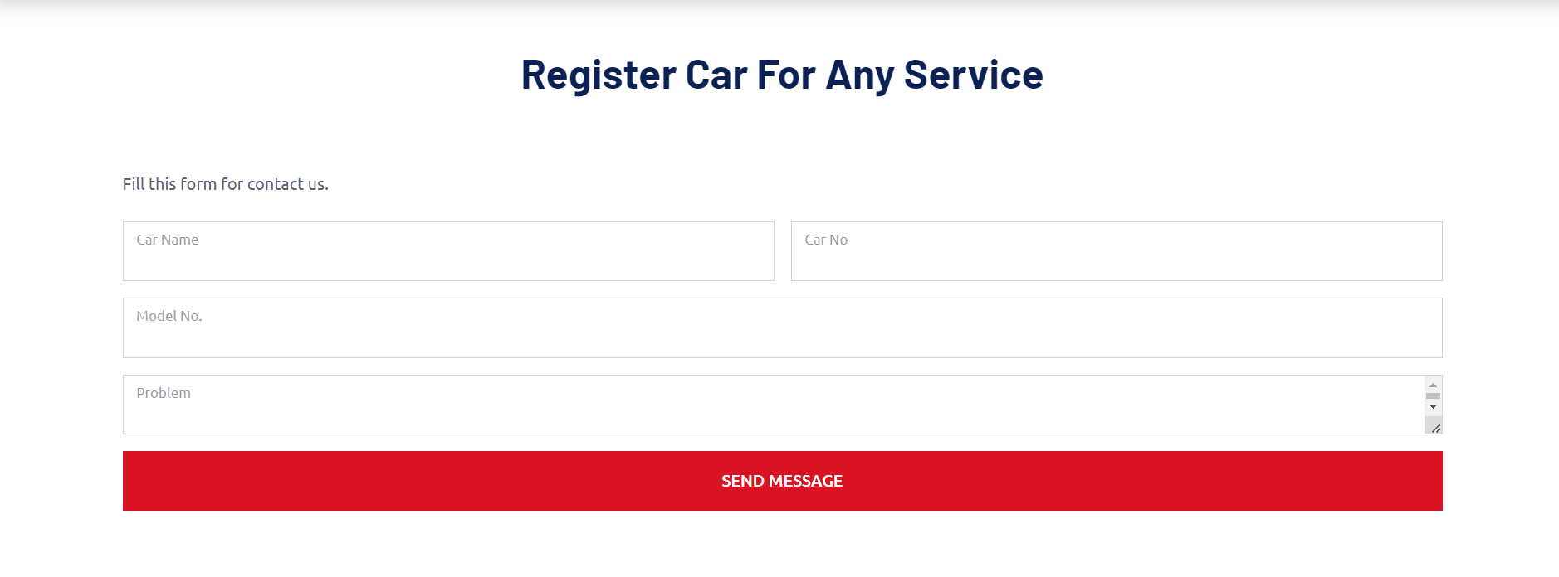

* **Login Page**

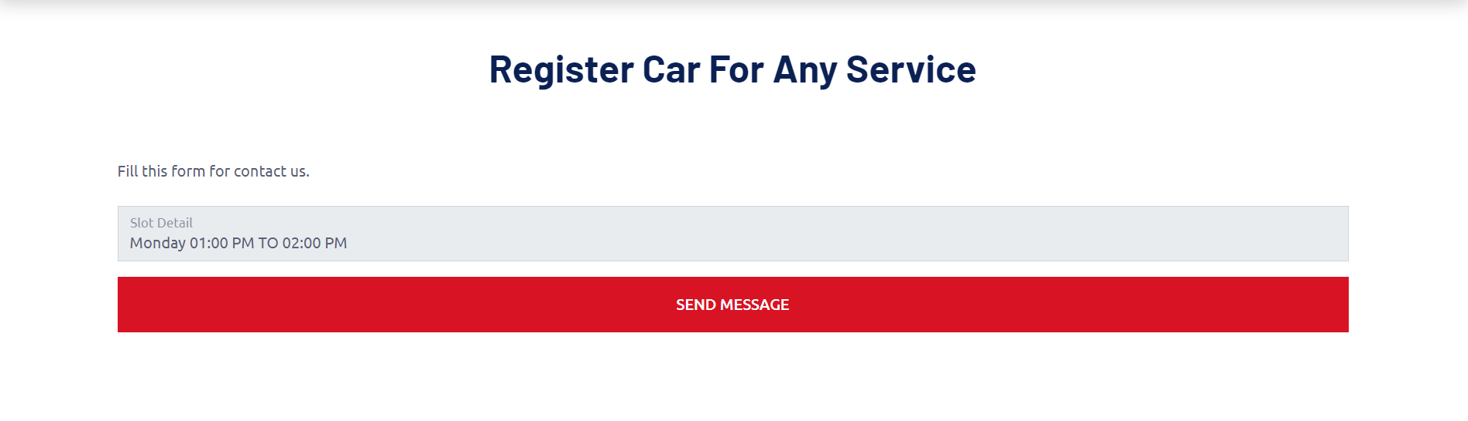

1. **LIMITATIONS AND FUTURE ENHANCEMENT**

* **Limitations :-**
* Live status
* Mobile Notification
* **Future Enhancement:-**
* In future, overall webapplication designing will be improved.
* We will provide live notification.
* Mobile notification will be provided soon.

1. **CONCLUSION**

The project report entitled CarServ has been completed successfully. This webapplication has been developed with much care that is free of errors and at a same time it is efficient and less time consuming. I have tried my level best to make this webapplication as dynamic as possible. This webapplication will be approved and implemented soon.

1. **REFERENCES AND BIBLIOGRAPHY**

All the references listed below were used to develop and design this webapplication and were also used for documentation. I am thankful to each and every person who helped me and supported for this project completion.

* Books :-
  + ASP.NET PROGRAMMING (Bharat & Co.)
* Android Libraries :-

AAMA 4 LINE MUKI DEJE

* Websites:-
  + themewagon.com
  + tutorialspoint.com
  + w3schools.com